The external dependencies needed to build AOI application.

1. QT 5.4.2. The download link <http://download.qt.io/archive/qt/5.4/5.4.2/>

Choose [qt-opensource-windows-x86-msvc2013_64_opengl-5.4.2.exe](http://download.qt.io/archive/qt/5.4/5.4.2/qt-opensource-windows-x86-msvc2013_64_opengl-5.4.2.exe)

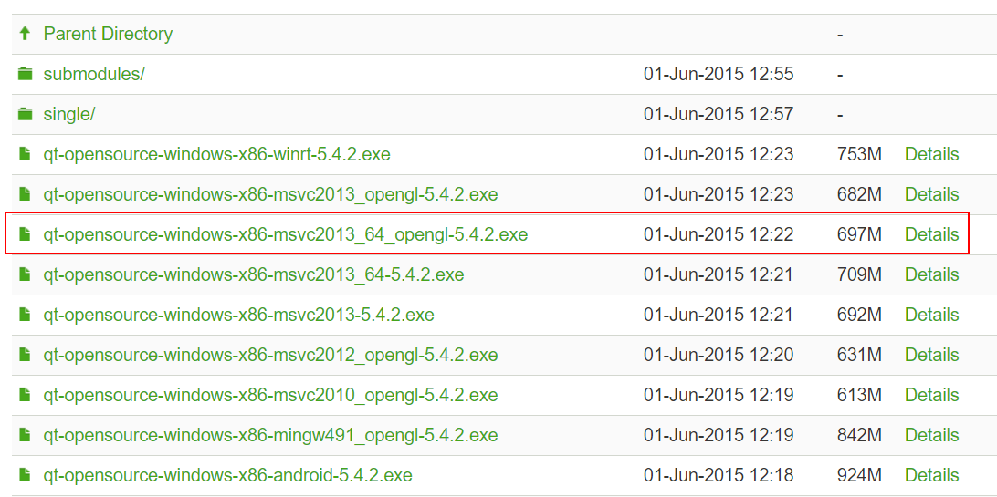

1. The Basler camera development library. <https://www.baslerweb.com/cn/support/downloads/software-downloads/pylon-5-0-11-windows/> , after download, when install, must select support GigE and Camera Link.
2. The DALSA camera development library. <http://www.teledynedalsa.com/imaging/products/software/sapera/lt/>

The internal dependencies needed.

1. VisionLibrary together with OpenCV 3.0. After get, put to .\lib\VisionLibrary
2. DataStoreAPI.
3. CryptLib.